KROnline NEWSLETTER
3435 OCEAN PARK BOULEVARD, SUITE 206
SANTA MONICA, CALIFORNIA 90405-3311
TELEPHONE: (310) 390-8000
FACSIMILE: (310) 397-0028
EMAIL: BSHADR@AOL.COM

Volume II Issue I January 1997

The KROnline Newsletter is intended to serve as a conduit for information and building ideas about the KR family of experimental aircraft. It is meant to share the knowledge that has been hard won by those who have gone before us. Education is the cornerstone to a quality built KR.

The article submissions each month are from KR builders and suppliers. Opinions express are solely those of the individual authors and not of KROnline. Any ideas or techniques discussed are to be duplicated and used at the sole risk of the experimental aircraft builder. KROnline does not endorse or warrant any certain outcomes.

Rand Robinson Engineering is in no way affiliated with KROnline and as such, does not formally endorse any information published in KROnline.



In this issue:

- Scratch built Fwd turtledeck/fuel tank

- Cooking composite parts

- Low cost fuel and oil sensing circuits

- Low voltage warning system for homebuilts

- Poor Man’s Hot Wire foam cutter

and much much more!



Adrean Carter’s 100% Scratch built KR2

Composite fuel tank construction by Mark Langford

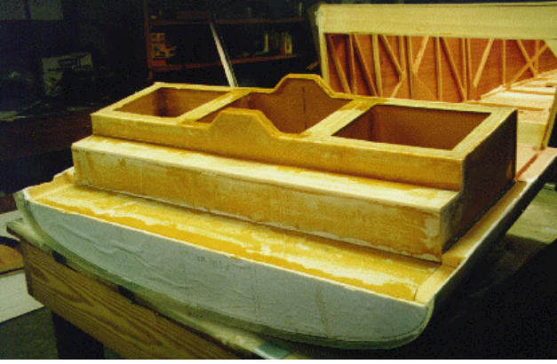
Fuel tank/forward deck. My tank was scratch built using 1/4” thick 4 pound density Clark foam (Last-o-foam). Two layers of 5.85 oz glass cloth were wetted with Safety Poxy II sandwiched on each side.. Hexcel's Safety Poxy II is no longer in production, but 2427 is the new replacement. One 5 quart epoxy kit is all that is needed for layups and assembly. Vinylester resin is also reputed to be fuelproof, and is very inexpensive. Given recent discussions on delamination of Hexcell products, I would use vinylester next time.
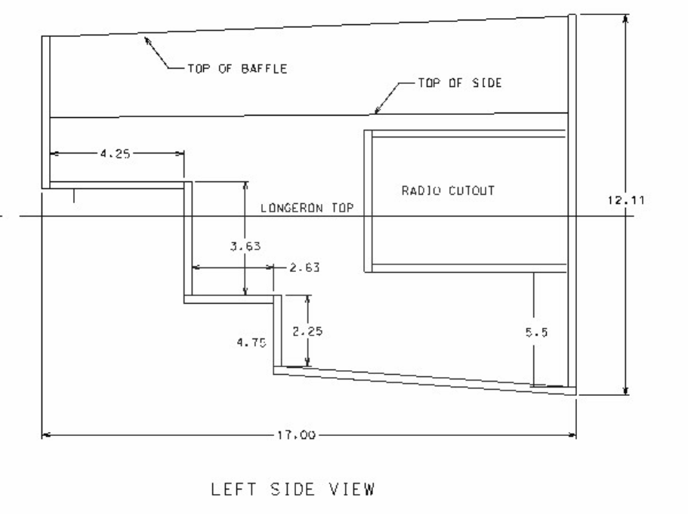

I modeled my tank in 3D on a CAD system in order to maximize fuel capacity, while providing ample room for instruments, avionics, and legs. I put my avionics cutout on the left side, because with a center stick, my left hand will be free to operate GPS and radios. Given my experience with the pitch sensitivity of the KR2, I don't think it's wise to try to fly one hands off. Originally, the fuel capacity of my design was 21.5 gallons, but after reflecting on the consequences of having that much volatility in my CG range, I decided to reduce it to 17.5 gallons.

The first step to constructing the tank is to spray or brush a layer of PVA (polyvinyl alcohol, available from Aircraft Spruce East and others) release agent onto a quarter inch piece of glass. I picked up a 3' x 3' piece of salvaged glass for $15. This glass sheet is required so that when the resin is pulled down to the glass surface, a perfectly flat surface results. Trying this on polyethylene will result in voids and pinholes. After the PVA cures, lay up two layers of 5.85 oz fiberglass on it. Be liberal with the epoxy resin here. A little extra weight is worth the headaches of several tiny pinholes. Immediately micro one side of a large pice of Clark foam and stick it to the fiberglass. Squeegee the clean side of the foam to ensure direct contact between the microed side and the uncured epoxy/fiberglass. Then apply micro to the top of the panel and lay up two more layers of fiberglass, and squeegee again. The end result is a “plyfoam sandwich”, with two layers of fiberglass on each side of the 1/4” foam.

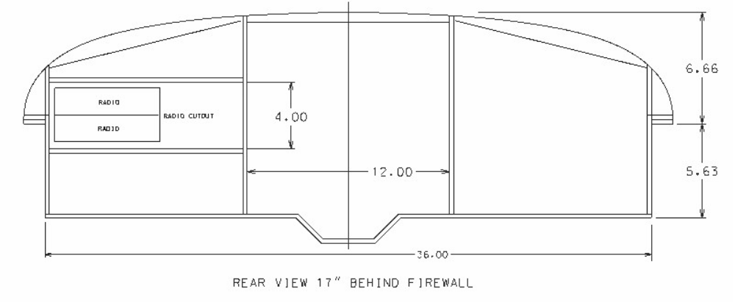
Decide on the shape of your instrument panel and draw a template for it. This is basically a mock instrument panel, and will extend to the outside of the two longerons, and will represent the outer shape of your forward deck. I made mine 7.5 inches taller than the longerons, with a nice elliptical shape, and it extends about 2”below the top of the longerons. Use the firewall template from the plans (or design your own more pleasing shape, like I did) as the front template for the tank. Once your templates are drawn up, cut out a firewall and instrument panel contour out of 3/4 inch particle board to be used as sanding guides, and clamp them in place. The aft end of the tank will be something that looks like a cross between the firewall and the instrument panel. If you make it a little large, it will simply be sanded to contour with the rest of the top of the tank.. The aft end of my tank is 17” from the rear of the firewall, which yields around 17 gallons of fuel, 7” of space for instruments, and 14” of space for radios.

You also need two baffles for the interior. Don't forget to leave openings at top and bottom, for air and fuel to circulate through. I made the bottom of my tank slope down as it goes aft, so that in a level or nose-up attitude, the fuel pickup will always be covered with fuel. There is also a sump in the center. This ensures that in straight and level flight, only about two ounces of fuel is unusable.

Position the foward end of the tank against the firewall, and the aft edge about 7” forward of the instrument panel. Cut out the two pieces which will sit on the two plywood firewall shelves and one which connects the two pieces together. Edge glue them together (with the smooth glass-like surface facing the inside of the tank) using flox and resin, and layup two layers of glass tape at each seam, overlapping in the corners. I used one strip of 1” tape, and one layer of 2” tape on top of that. The end result will be four layers of glass in each corner, with lots of resin to ensure against pinholes.
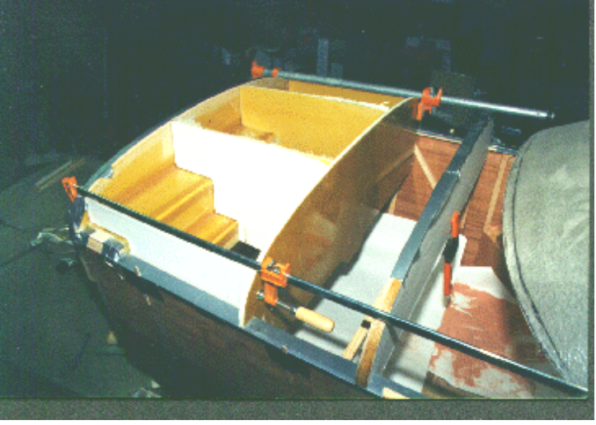

Install the two tank sides and the two baffles along with the aft end of the tank, edge glueing all joints with flox and resin and clamp lightly together.

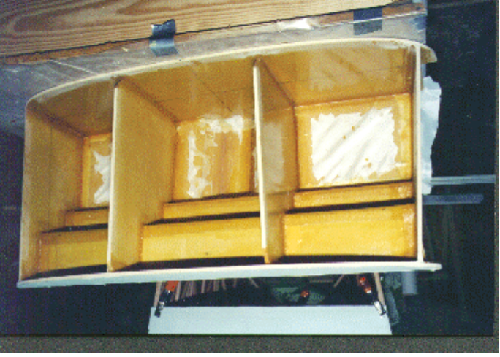

Here, the bottom is being temporarily installed while two more layers of glass tapes are used to create flanges between the side walls and the bottom. Peelply is used to prevent the bottom from sticking to the flanges. After curing, the bottom is removed so that the top can be constructed and sealed from the inside. Later, lots of resin is spread on the flanges, and the bottom is reinstalled permanently.

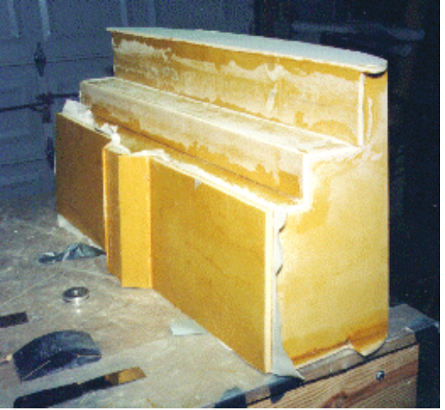

A view showing the bottom of the tank temporarily installed during flange creation. Duct tape was used during the process to hold the bottom tightly against the sides of the tank. No tapes are installed on the outside of the tank yet, but there's no reason why they can't be.

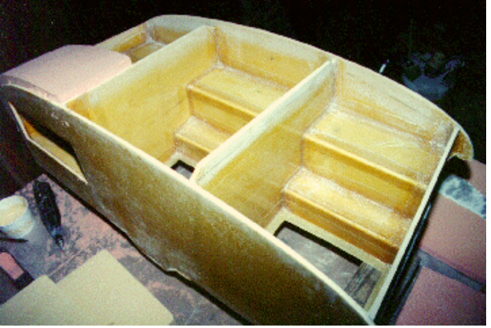

The top of the tank is constructed from two inch urethane foam, with the bottom side laid up with two layers of fiberglass on glass again, as before. It is then trimmed to fit into the top of the tank in three or four pieces. The fiberglass layer on the bottom of the foam should be a nice tight fit inside the top of the tank.

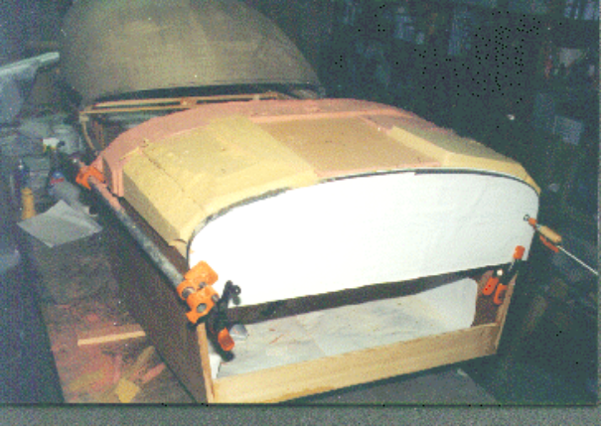

Flox them in place with a generous fillet in all corners. Then, working inside the tank from the bottom, immediately install the two fiberglass tapes around all joints again.. For mounting, I installed piano hinges
between the longerons and the tank sides, where the two meet. The fuel tank is now removable by simply pulling the pins. Until these hinges are installed, the tank is actually resting on the ears of the front and rear tank walls.

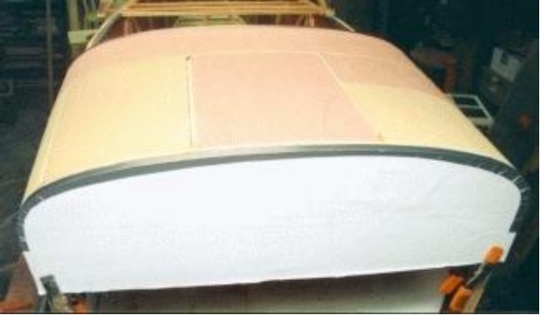
Sand the top of the tank to contour using a sanding block long enough to span both instrument panel and firewall plywood templates. Cover the longerons with duct tape to prevent damage to them.

The resulting top surface is now ready to be 'glassed.

Lay up the top of the tank with one layer of 5.85 oz fiberglass cloth and one layer of fine weave 1.5 oz cloth on the outside. Squeegee on peelply over the tank top to absorb excess resin. After curing, use micro to blend the edges of the tank to the fuselage sides. Install the fuel cap either forward or aft, depending on whether your gear is conventional or tricycle, and flox into place, reinforcing from the inside with fiberglass tape. Locate the fuel cap a few inches from aft or foward edge, to ensure that the tank can't be filled completely full. This allows a small air space for expansion of fuel after it warms up. Otherwise, fuel will be expelled out of the vent tube. Install the fuel sending unit. I used a universal VDO adjustable sending unit, available for about $25.00. It has a range of from 6-24”or so. Don't forget to connect a ground to it. Ensure that there are passages at the top of the baffles on each end for air to pass through, and apply epoxy to any exposed foam. Install a 1/4” aluminum tube as a vent. It entes the tank at a high location, and should end internally at the highest point of the tank. After installing the finger strainer in the tank bottom, epoxy the bottom on, and reinforce with the now familiar two layers of 'glass tapes. You should now pressure test your tank with about 1 psi of pressure. Too much and it'll blow! I used oxygen from my acetylene tank, because it has a very accurate pressure regulator.

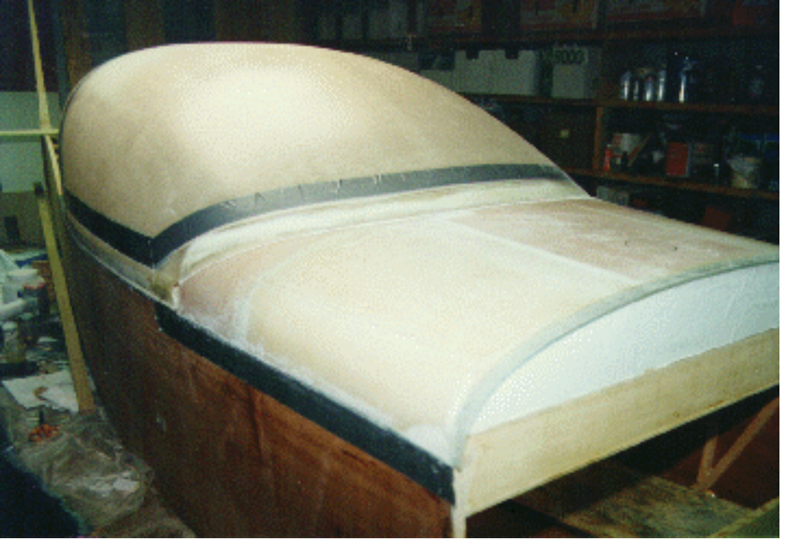

The finished product with canopy and frame installed. The canopy also needs to be at least blocked in place during the panel mockup exercise so that the front deck will conform to the canopy’s natural shape. This way stresses aren’t induced into the plexiglas that could later cause cracking or crazing.

For more info on my project, visit my web page at http://www.traveller.com/~griffon/kr2s.html and click on Mark Langford’s Project.

Cure those Composite Parts with a little Heat!
By Abby Gayle

I've been lurking long enough, Its about time I try to make a contribution. Hopefully this will be beneficial to someone. As the temperature in the North Country starts to plummet, I am forced to
resurrect my "cure chamber" to permit my epoxy to cure in a thermally controlled environment. It is neither original, complex or expensive. It is cheap, simple and provides temperature control to +/- 3 deg F. I do both wet lay ups and vacuum bagging depending on the part / application. I have used a plethora of resin systems. My current favorites are manufactured by PTM&W (Aeropoxy) I prefer to cure at a min. temp. of 95 deg F for 24 hrs. Raising the ambient temp. of my hanger is cost prohibitive and I feel that localized heat in the form of heat lamps or space heaters is to haphazard. The obvious solution (at least for small and medium size parts) was a cure chamber / oven.

Chamber Configuration
1) The chamber base / bottom is .125" thick X 4' x 8' aluminum. It is supported on a wood frame. I added legs to raise it to a convenient work height.

2) The back, top and front of the chamber are 1" x 2' x 8' Styrofoam from the local builders supply.

3) The sides are 1" x 23" x 24" Styrofoam.

4) The sides, back and top are secured in position w/ tooth picks (no adhesive)

5) The front is removable and is held in position by the weight of the top and an occasional tooth pick. This "5 sided" Styrofoam box is not secured to the aluminum base.

6) Parts are held off the base of the chamber by wooden racks and / or hooks.

7) I inserted several thermometers at strategically located positions to monitor temperature.

8) Conductive heat is supplied to the chamber by directing any combination of heat lamps and / or infer red heat (Mr. Heater-propane) at the underside of the aluminum base. (ie--aim the heat up at the exposed aluminum from underneath)

9) Some testing is required to determin the proper combination of heat sources.

Notes
1) I know I lose some thermal efficiency as the base is larger than the chamber, but I like the extra space for a staging area. If increased efficiency is a primary concern:
a) An internal heat source (light bulbs) could be utilized if care is exercised to avoid localized over heating
b) Styrofoam "skirts" could be added to enclose the area between the chamber base and the hanger floor.

2) I use a smaller chamber of similar construction (internal heat) to store my epoxy at a relative stable temp.

3) This chamber has the advantage of being a temperary structure if you are
space limited.

The scoop on Multi-Grade engine Oil

There is a unbelievable amount of oil 'misinformation' that resides in our collective 'knowledge'. There are all the arguments about which break-in oil to use, whether or not to use 50 weight (auto) oil in a V-6 converted for airplane use, which (if any) additive is necessary, how
often to change oil, etc.

There was an article in the General Aviation News & Flyer recently authored by Kas Thomas (editor of TBO Advisor). The article cites recent studies that show the multi-grade oils as not being as good as plain old SAE 30.

'Now it turns out there may be solid scientific evidence that single-weight oils protect engines better than their multi-viscosity counterparts. A recent study published by the Society of Automotive Engineers (the folks whose initials adorn the top of every can of oil sold in this
country) casts doubt on the theory that multigrades are better all-around lubricants than straight-weight oils.'

'Last March, Mercedes-Benz engineers Rudolf Thom and Karl Kollman, along with Shell Oil engineers Wolfgang Warnecke and Mike Frend, authored SAE technical paper 951035, which discussed recent research results involving a variety of oils. Among the many interesting findings presented in the paper was a graph showing cylinder-wall wear rates versus cylinder wall temperature in an operating engine.'

'Three tests in a 2.4-liter, four-cylinder Mercedes-Benz OM 616 engine compared three kinds of oils. In one test sequence, a straight 30-weight oil was used; in another, 10W-30 multigrade; and in the third, straight 10-weight oil. In each case, the engine was operated at fixed speed, torque and temperature conditions until constant wear rates were observed. Wear rates were then plotted against cylinder wall temperature.'

'While two of the oils turned in very similar wear performance, one oil stood out as protecting the engine against wear at the extremes of temperature. That oil was plain SAE 30 (straight-grade 30-weight). At either extreme of temperature, the maximum wear rate with 10W-30 was more than double that of the straight SAE 30 oil. The worst performance was turned in by straight 10-weight.'

'These finding should come as no surprise because , in general, thicker oils make for thicker oil films and the thicker the oil film the better the wear protection. What's surprising is that a 10W-30 oil, which is supposed to have viscosity comparable to an SAE 30 oil at high temperatures, does not provide wear protection at least equal to that of a 30-weight unmodified oil. The simplest explanation, it appears, is that the base stock from which a 10W-30 multigrade is made (namely, 10-weight oil) is fundamentally not as good a lubricant as a 30-weight base stock. It would also appear that viscosity-index (VI) improvers are not, in and of themselves, robust lubricants.'

It should be noted that some multigrade oils are made from base stocks that have higher viscosity than 10W. Shell's 15W-50 starts life as an SAE 30 and Phillips X/C starts life as a 20-weight.

